# General Description

## 2.1 Product Perspective

The App doesn't work independently. It has to work together with the GPS and the bot.

## 2.2 User Characteristics

There are several users of the Application:

*Customer*

The customer interacts with the Application using screens. It must be very easy for them to use the Application. They should be supported by the system in every possible way.

*Admin*

It should be easy to maintain the whole system. The Admin should be the only person that is allowed to connect a new application.

# Specify Requirements

## 3.1 Functional Requirements

The functional requirements are organized in three sections: First requirements of the Admin, second requirements of the System and third one of the bot.

### 3.1.1 Requirements of the Admin

The requirements for the automated teller machine are organized in the following way: General requirements, requirements for authorization, requirements for a transaction.

*General*

*Functional requirement 1*

*Description*

The admin administrates the application

*Input*

The admin puts the username and password to login the app

*Processing*

Check the password and username

*Output*

The admin has all the authorization of the app

*Functional requirement 2*

*Description*

The admin initializes the zone the devices contains the app (Location).

*Process*

Know the app location

*Output: specify the location*

*Functional requirement 3*

*Description*

The admin enters the data of the app (Restaurants, Temples, Hostels, …..)

*Input*

the data of the app

*Processing*

Save the data of the app

*Output*

Saves the data

*Functional requirement 4*

*Description*

The customer clicks icon.

*Input*

Touch icon.

*Processing*

Display icon clicked.

*Output*

Data icon clicked.

*Functional requirement 5*

*Description*

The customer specify the destination desired.

*Input*

Touch icon clicked.

*Processing*

Process the data of location desired.

*Output*

Data information.

*Functional requirement 6*

*Description*

The customer destination of location desired.

*Input*

Touch icon clicked.

*Processing*

Process the data of location desired.

*Output*

Data information.

*Functional requirement 7*

*Description*

The location of the place.

*Input*

Click map.

*Processing*

Enter GPS.

*Output*

Display the location of the place.

*Functional requirement 8*

*Description*

The customer clicks chat bot if the place not found.

*Input*

Click chat bot.

*Processing*

Enter Chat bot.

*Output*

Display chat bot.

*Functional requirement 9*

*Description*

Know another places.

*Input*

Click back.

*Processing*

Back home page.

*Output*

Display home page.

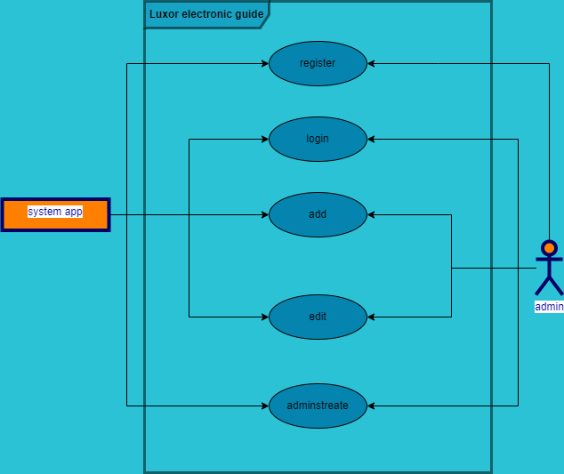

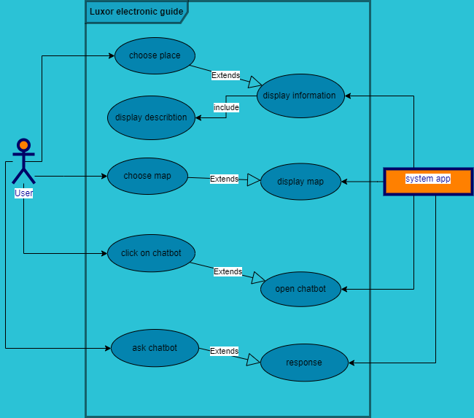

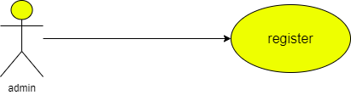

|  |  |  |
| --- | --- | --- |
| **Use case name** | Register | |
| **Unique ID** | 001 | |
| **Area** | Application | |
| **Actor(s)** | Admin | |
| **Description** | Admin creates account | |
| **Triggering Event** | Admin click “Register” button in the application | |
| **Preconditions** | * The admin needs to download application on monitor | |
| **Post conditions** | - Admin has successfully created account | |
| **Assumptions** | * Admin has application * A valid data | |
| **Steps Performed** | | **Information for Steps** |
| 1. Open application 2. Click on “Create Account” button   3- Validation of entered data by application | | Step 3: Name, Username, Password, E-mail |
| **Extensions (Alternative Flows)** | * If the downloading interrupted for any reason, use should try again and download it * If admin entered a non-valid data, a warning message should   appear to him | |

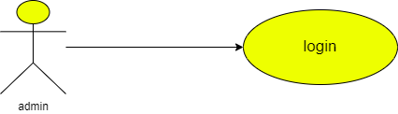

|  |  |  |
| --- | --- | --- |
| **Use case name** | Login | |
| **Unique ID** | 002 | |
| **Area** | Application | |
| **Actor(s)** | Admin | |
| **Description** | Admin login to his account | |
| **Triggering Event** | Admin click “Login” button in the application | |
| **Preconditions** | * The admin needs to download application then open it * The admin needs to have account | |
| **Post conditions** | - Admin has successfully logged in to his account | |
| **Assumptions** | * Admin have application * A valid data | |
| **Steps Performed** | | **Information for Steps** |
| 1. Open application 2. Admin enters his data 3. Click on “Login” button 4. Validation of entered data by application | | Step 2: E-mail, Password |
| **Extensions**  **(Alternative Flows)** | - If admin entered a non-valid data, a warning message should  appear to him | |

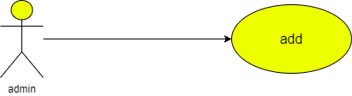

|  |  |  |
| --- | --- | --- |
| **Use case name** | Adding information | |
| **Unique ID** | 001 | |
| **Area** | Application | |
| **Actor(s)** | Admin | |
| **Description** | Admin adds data | |
| **Triggering Event** | Admin enters to database | |
| **Preconditions** | - The admin needs to login in to his account | |
| **Post conditions** | - Admin has successfully added data to application | |
| **Assumptions** | * Admin has application * A valid data | |
| **Steps Performed** | | **Information for Steps** |
| 1- Open application 2- Admin log in  3- admin enters database  4- Admin adds the new information in the system   1. Validation message | | Step 2: E-mail, Password |
| **Extensions (Alternative Flows)** | - If admin entered a non-valid data, a warning message should appear to him | |

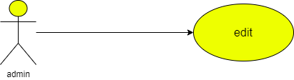

|  |  |  |
| --- | --- | --- |
| **Use case name** | Edit information | |
| **Unique ID** | 001 | |
| **Area** | Application | |
| **Actor(s)** | Admin | |
| **Description** | Admin edits data | |
| **Triggering Event** | Admin enters to database | |
| **Preconditions** | - The admin needs to login in to his account | |
| **Post conditions** | - Admin has successfully added data to application | |
| **Assumptions** | * Admin has application * A valid data | |
| **Steps Performed** | | **Information for Steps** |
| 1- Open application 2- Admin log in  3- admin enters database  4- Admin edits the information in the system   1. Validation message | | Step 2: E-mail, Password |
| **Extensions (Alternative Flows)** | - If admin entered a non-valid data, a warning message should appear to him | |

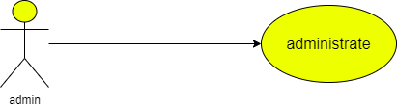

|  |  |  |
| --- | --- | --- |
| **Use case name** | Administrates information | |
| **Unique ID** | 001 | |
| **Area** | Application | |
| **Actor(s)** | Admin | |
| **Description** | Admin administrates the data about the app | |
| **Triggering Event** | Admin enters to database | |
| **Preconditions** | - The admin needs to login in to his account | |
| **Post conditions** | - Admin has successfully added data to application | |
| **Assumptions** | * Admin has application * A valid data | |
| **Steps Performed** | | **Information for Steps** |
| 1- Open application 2- Admin log in  3- admin enters database  4- Admin edits the information in the system   1. Validation message | | Step 2: E-mail, Password |
| **Extensions (Alternative Flows)** | - If admin entered a non-valid data, a warning message should appear to him | |

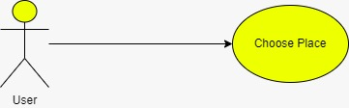

|  |  |  |
| --- | --- | --- |
| **Use case name** | * Choose place | |
| **Area** | * Application | |
| **Actor(s)** | * User | |
| **Description** | * The user select the desired place | |
| **Triggering Event** | * User selects the place on the screen | |
| **Preconditions** | - The user needs to be on the application | |
| **Post conditions** | - User has successfully entered the application | |
| **Assumptions** | * User has to use application | |
| **Steps Performed** | | **Information for Steps** |
| 1- Open application 2- User enters the application  3- User selects the icon | |  |
| **Extensions (Alternative Flows)** | - If user entered a non-valid data, a warning message should appear to him | |

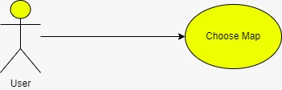

|  |  |  |
| --- | --- | --- |
| **Use case name** | * Choose map | |
| **Area** | * Application | |
| **Actor(s)** | * User | |
| **Description** | * The user select the map to locate the place | |
| **Triggering Event** | * User selects the map button | |
| **Preconditions** | - The user needs to be on the application | |
| **Post conditions** | - User has successfully entered the application | |
| **Assumptions** | * User has to use application | |
| **Steps Performed** | | **Information for Steps** |
| 1- Open application 2- User enters the application  3- User selects the icon  4-User selects the map icon | |  |
| **Extensions (Alternative Flows)** | - If user entered a non-valid data, a warning message should appear to him | |

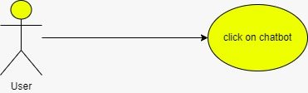

|  |  |  |
| --- | --- | --- |
| **Use case name** | * Click on chat bot | |
| **Area** | * Application | |
| **Actor(s)** | * User | |
| **Description** | * The user select the Chat bot | |
| **Triggering Event** | * User selects the chat bot icon | |
| **Preconditions** | - The user needs to be on the application | |
| **Post conditions** | - User has successfully entered the application | |
| **Assumptions** | * User has to use application | |
| **Steps Performed** | | **Information for Steps** |
| 1- Open application 2- User enters the application  3- User selects the chat bot icon | |  |
| **Extensions (Alternative Flows)** | - If user entered a non-valid data, a warning message should appear to him | |

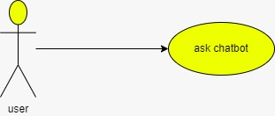

|  |  |  |
| --- | --- | --- |
| **Use case name** | * Ask chat bot | |
| **Area** | * Application | |
| **Actor(s)** | * User | |
| **Description** | * The user ask the Chat bot | |
| **Triggering Event** | * User selects the chat bot icon | |
| **Preconditions** | - The user needs to be on the application | |
| **Post conditions** | - User has successfully entered the application | |
| **Assumptions** | * User has to use application | |
| **Steps Performed** | | **Information for Steps** |
| 1- Open application 2- User enters the application  3- User selects the chat bot icon  4-User starts to ask it about what he needs to know | |  |
| **Extensions (Alternative Flows)** | - If user entered a non-valid data, a warning message should appear to him | |

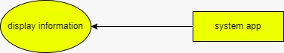

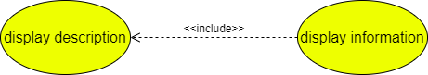

|  |  |  |
| --- | --- | --- |
| **Use case name** | * Display information | |
| **Area** | * Application | |
| **Actor(s)** | * System | |
| **Description** | * The data user selects shown on the application | |
| **Triggering Event** | * Non | |
| **Preconditions** | - The system need to be used | |
| **Post conditions** | - User has successfully entered the application and the application is on | |
| **Assumptions** | * The system is on | |
| **Steps Performed** | | **Information for Steps** |
| 1- Open application 2- User enters the application  3- User selects the desired information | |  |
| **Extensions (Alternative Flows)** | - If there is non-valid data, a warning message should appear to him | |

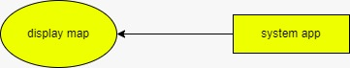

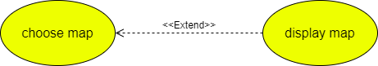

|  |  |  |
| --- | --- | --- |
| **Use case name** | * Display map | |
| **Area** | * Application | |
| **Actor(s)** | * System | |
| **Description** | * The user selects map to know the location | |
| **Triggering Event** | * Non | |
| **Preconditions** | - The system need to be used | |
| **Post conditions** | - User has successfully entered the application and the application is on | |
| **Assumptions** | * The system is on | |
| **Steps Performed** | | **Information for Steps** |
| 1- Open application 2- User enters the application  3- Click on the map | |  |
| **Extensions (Alternative Flows)** | - If there is no internet , a warning message should appear to him | |

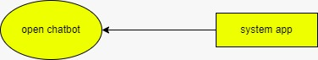

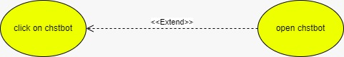

|  |  |  |
| --- | --- | --- |
| **Use case name** | * Open chat bot | |
| **Area** | * Application | |
| **Actor(s)** | * System | |
| **Description** | * The system calls chat bot | |
| **Triggering Event** | * Non | |
| **Preconditions** | - The system need to be used | |
| **Post conditions** | - User has successfully entered the application and the application is on | |
| **Assumptions** | * The system is on | |
| **Steps Performed** | | **Information for Steps** |
| 1- Open application 2- User enters the application  3- User selects the chat bot | |  |
| **Extensions (Alternative Flows)** | - If there is non-valid data, a warning message should appear to him | |



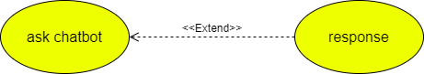

|  |  |  |
| --- | --- | --- |
| **Use case name** | * Response | |
| **Area** | * Application | |
| **Actor(s)** | * System | |
| **Description** | * Application response to user | |
| **Triggering Event** | * Non | |
| **Preconditions** | - The system need to be used | |
| **Post conditions** | - User has successfully entered the application and the application is on | |
| **Assumptions** | * The system is on | |
| **Steps Performed** | | **Information for Steps** |
| 1- Open application 2- User enters the application  3- User askes chat bot  4- System response to him | | Step1- Ask chat bot |
| **Extensions (Alternative Flows)** | - If there is non-valid data, a warning message should appear to him | |